B. Receive Pending Assets

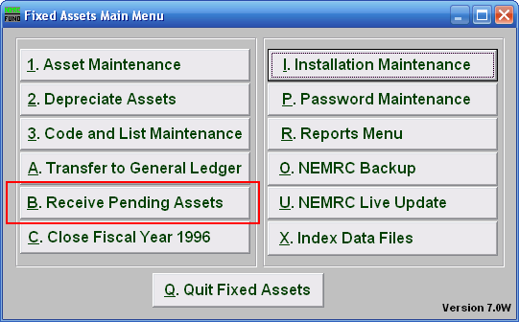
Click on “B. Receive Pending Assets” from the Main Menu and the following window will appear:

Receive Pending Assets

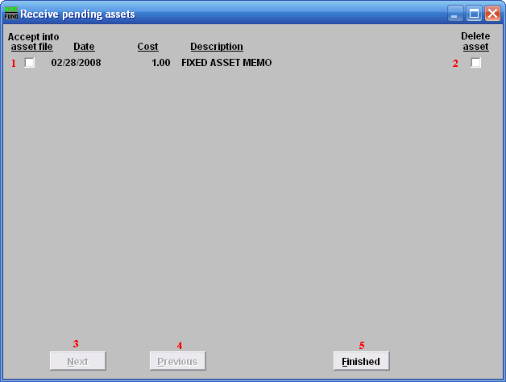
- Accept into asset file: Click on the box next to the date you want to Accept into the asset file. This will take you to the Asset Maintenance screen.

- Delete asset: Click on the box to Delete the asset, and the window shown below will appear.

- Next: When multiple assets are available to accept, the “Next” button will be active and present another asset to process through.

- Previous: When multiple assets are available to accept, the “Previous” button will be active and allow another asset not completed to be seen.

- Finished: Click this button when you have completed this screen. If you have Accepted an item it will take you to Asset Maintenance. If you have not it will close and return to the Main Menu.

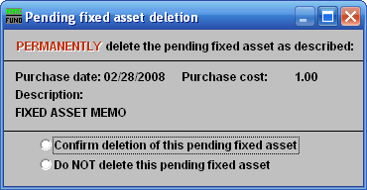
Clicking “Confirm deletion of this pending fixed asset” will delete this pending Fixed Asset.

Clicking “Do NOT delete this pending fixed asset” will return you to the previous screen without deleting the Fixed Asset.

